
Customer Service Support
Utilizing machine learning to classify, prioritize and summarize issues
Hoai Nhan Nguyen | 10/27/24 | Strategic Thinking



Assessment Cover Page

Student Full Name | Hoai Nhan Nguyen
Student Number | sba24098
Module Title | Strategic Thinking
Assessment Title | CA 1 – Capstone Project Proposal
Assessment Due Date | 27-10-2024
Date of Submission | 27-10-2024
Declaration
By submitting this assessment, I confirm that I have read the CCT policy on academic misconduct and understand the implications of submitting work that is not my own or does not appropriately reference material taken from a third party or other source.
I declare it to be my own work and that all material from third parties has been appropriately referenced.
I further confirm that this work has not previously been submitted for assessment by myself or someone else in CCT College Dublin or any other higher education institution.

Contents
Introduction 1
Objectives and Problem Definition 1
Project Scope 2
Overview 2
Project Functionality 2
Project Boundary 2
In Scope 2
Out of Scope 2
Model Development 3
Ticket multi-classification and prioritization 3
Ticket summarization 3
Project Timeline 4
Semester 1 4
Semester 2 4
Data Sources 5
Ethical Considerations 5
References 6
Bibliography 7

Introduction

From working within a customer support team, our top priority is the customer experience and resolving their product-related issue. I have found that customers would get frustrated if their case hasn’t been handled correctly or there is a delay in resolving their case. This can be caused due to “missing knowledge and multiple re-routings between support agents“. This can negatively influence the customer experience which could lead the customer to discontinue using our product.
I will be developing a machine learning solution to tackle this issue by minimizing “the time the support ticket spends in the system”. There are many forms of customer support communication, this capstone project will focus on email base support and reducing the resolution time on solving customer issues. The factors that could delay the resolution time for a customer would be the following below:

- Tickets being sent to the incorrect team.
- Tickets not being prioritized correctly.
- Support agents’ mis-understanding the case.

I will address the above issues by implementing machine learning to classify which team should tackle the issue, predicting its prioritization and summarizing the core customer issue. This implementation can be used to improve ticket routing and capturing customer issues for support agents.

Objectives and Problem Definition

My objective in this capstone project is to use machine learning methods to improve customer experience by reducing the resolution time on solving customer issues. I will be implementing natural language processing techniques to “extract the significance of a ticket from its text “ and use machine learning models to classify, prioritize and summarize the case. It will have the following functionalities below:

- Classifying tickets based on its queue category. This will identify the appropriate team that should handle the issue.
- Predicting the prioritization of a ticket from low, medium or high. This will identify the urgency of the case.
- Summarising a ticket to get an overview of the issue. This will help the support agent to identify the core customer issue.

These functionalities will solve the problem of tickets being sent to the incorrect team, inaccurate prioritization and misinterpretation of customer issues. The machine learning implementation will provide consistency of handling tickets correctly to reduce operational errors from support agents.

Project Scope

Overview
The end of semester two, I will provide a Jupyter notebook of my machine learning implementation and a report on my analysis. Below I have provided further information on the project functionality and scope.

Project Functionality

Data input | Retrieving information on a customer support ticket.
Machine learning model | Using natural language processing techniques and machine learning models to analyze the customer support ticket.
Data output | Providing the following below:  - Classified ticket queue.  - Predicted priority level.  - Summarized customer issue.

Project Boundary

In Scope
1. | Data collection, exploration, and preprocessing - Collecting customer support ticket dataset as a csv file. Conducting an exploratory data analysis and data pre-processing with the dataset.
2. | Model Development - Implementing machine learning models to provide the functionality for multi-classification, summarization and prioritization.
3. | Multi-classification - Classifying customer support tickets into predefined queue categories based on the customer issue.
4. | Prioritization - Predicting ticket priority as low, medium or high based on the issue.
5. | Summarization - Generating a summary of the issue of the ticket
6. | Evaluation and optimisation - Conducting a machine learning model evaluation and optimisation to improve its performance.

Out of Scope
1. | Integrating machine learning models to an existing customer support system.
2. | Using a Database to store and retrieve dataset of the machine model.
3. | Developing an automated workflow to assign the tickets to a particular team.
4. | Developing an automated response to the customer based on the ticket issue.
5. | Creating a dashboard user interface on the machine learning model for analysis.
6. | Providing machine learning suggestions on how to resolve the issue.

Model Development

Ticket multi-classification and prioritization
Machine Learning Algorithm Options | Naive Bayes, Support Vector Machine, Random Forest or Decision Tree.
Model evaluation | Accuracy, Precision, Recall, F1 score, ROC-AUC or Confusion Matrix

Ticket summarization
Machine Learning Algorithm Options | Term Frequency-Inverse Document Frequency, LexRank, TextRank or Latent Semantic Analysis.
Model evaluation | Recall-Oriented Understudy for Gisting Evaluation or Cosine Similarity

Project Timeline

In this section, I have provided a high-level timeline for the capstone project that spans over the two semesters. I have broken down the project into milestones that include the estimated completion dates. Each semester will include documentation for each phase that has been completed.

Semester 1

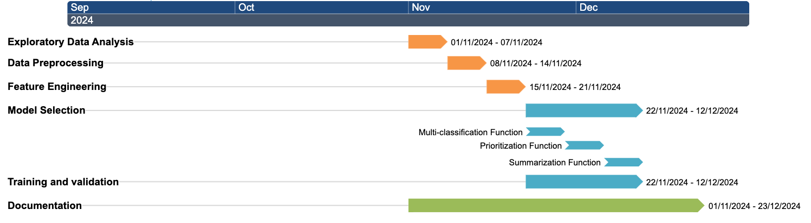
Semester 2
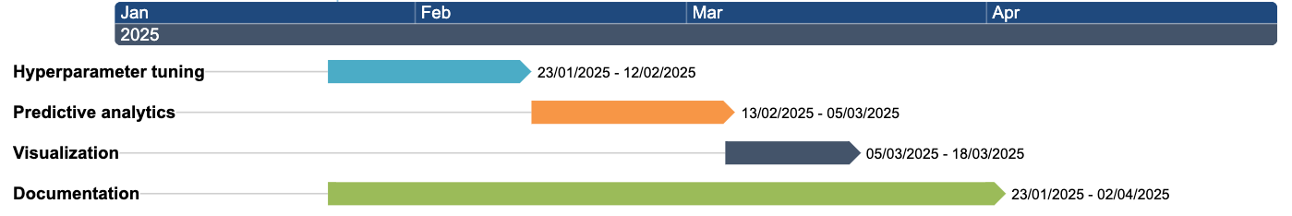

Data Sources
For my capstone project I will be using the Customer Support Emails - Ticket System - Helpdesk dataset from the Kaggle website. It provides data that includes customer support ticket features that I can use for my machine learning implementation. It provides features that include the ticket priority, the ticket queue based on which team should tackle the case, and the body of the customer email. The dataset contains 600 ticket examples that can be used for the machine learning model.
The dataset is licensed by Creative Commons Attribution 4.0 International. I can use the dataset for educational purposes, if I provide appropriate credit and reference of its usage.

Ethical Considerations
From the Ethics Guidelines for Trustworthy AI (EU), developing a “trustworthy AI has three components”. These three components relate to complying with the law, adhering to ethical principles, and being robust from both a technical and social perspective.
As the capstone project will be related to customer support tickets, it should comply with GDPR standards when using the dataset for the machine learning model. The dataset should remove customer PII information and only use necessary data for its functionality. It will be important that all potential biases are considered as well. When classifying and prioritizing, it should be based on the ticket issue and not the customers demographic background to prevent discrimination. The performance of the machine learning model should always be evaluated to ensure its expected functionality to improve both the agent and customer experience.

GitHub Documentation Link - https://github.com/CCT-Dublin/ca1-capstone-project-proposal-sba24098

References

Truss, M. and Boehm, S. (2024) ‘AI-based Classification of Customer Support Tickets: State of the Art and Implementation with AutoML’, Proceedings of the IWEMB 2021/2022: Fifth and Sixth International Workshop on Entrepreneurship, Electronic and Mobile Business [Preprint]. Available at: https://research.ebsco.com/linkprocessor/plink?id=54e9ee0f-a797-3f1f-b754-ba84ad754cbe (Accessed: 19 October 2024). Page 358
Borg, A. et al. (2021) ‘E-mail classification with machine learning and word embeddings for improved customer support’, Neural Computing & Applications, 33(6), pp. 1881–1902. doi:10.1007/s00521-020-05058-4. page 1882
Renato Bruni, Gianpiero Bianchi and Pasquale Papa (2023) ‘Hyperparameter Black-Box Optimization to Improve the Automatic Classification of Support Tickets’, Algorithms, 16(1), p. 46. doi:10.3390/a16010046. page 4
Tobias Bueck (2024). Customer Support Emails - Ticket System - Helpdesk [Dataset]. Available at: https://www.kaggle.com/datasets/tobiasbueck/multilingual-customer-support-tickets (Accessed: 19 October 2024). Licensed under: Creative Commons Attribution 4.0 International (CC BY 4.0) https://creativecommons.org/licenses/by/4.0/.
European Commission (2019). Ethics guidelines for trustworthy AI. Available at: https://ec.europa.eu/newsroom/dae/document.cfm?doc_id=60419 (Accessed: 19 October 2024). Page 5 Bibliography - Truss, M. and Boehm, S. (2024) ‘AI-based Classification of Customer Support Tickets: State of the Art and Implementation with AutoML’, Proceedings of the IWEMB 2021/2022: Fifth and Sixth International Workshop on Entrepreneurship, Electronic and Mobile Business [Preprint]. Available at: https://research.ebsco.com/linkprocessor/plink?id=54e9ee0f-a797-3f1f-b754-ba84ad754cbe (Accessed: 19 October 2024). - Borg, A. et al. (2021) ‘E-mail classification with machine learning and word embeddings for improved customer support’, Neural Computing & Applications, 33(6), pp. 1881–1902. doi:10.1007/s00521-020-05058-4. - Renato Bruni, Gianpiero Bianchi and Pasquale Papa (2023) ‘Hyperparameter Black-Box Optimization to Improve the Automatic Classification of Support Tickets’, Algorithms, 16(1), p. 46. doi:10.3390/a16010046. - D’Silva, J. and Sharma, U. (2023) ‘Automatic Text Summarization of Konkani Folk Tales Using Supervised Machine Learning Algorithms and Language Independent Features’, IETE Journal of Research, 69(9), pp. 6162–6175. doi:10.1080/03772063.2021.1987993. MONTGOMERY, L. et al. Customer support ticket escalation prediction using feature engineering. Requirements Engineering, [s. l.], v. 23, n. 3, p. 333–355, 2018. DOI 10.1007/s00766-018-0292-3. Disponível em: https://research.ebsco.com/linkprocessor/plink?id=a1d0ed3c-aea8-3918-85f0-f296c6f9472e. Acesso em: 19 out. 2024. - Julie Mehan (2022) Artificial Intelligence : Ethical, Social, and Security Impacts for the Present and the Future. Ely: ITGP. Available at: https://research.ebsco.com/linkprocessor/plink?id=f5122a08-e010-3b99-aedd-0b425c064cd8 (Accessed: 19 October 2024). - European Commission (2019). Ethics guidelines for trustworthy AI. Available at: https://ec.europa.eu/newsroom/dae/document.cfm?doc_id=60419 (Accessed: 19 October 2024). - Tobias Bueck (2024). Customer Support Emails - Ticket System - Helpdesk [Dataset]. Available at: https://www.kaggle.com/datasets/tobiasbueck/multilingual-customer-support-tickets (Accessed: 19 October 2024). Licensed under: Creative Commons Attribution 4.0 International (CC BY 4.0) https://creativecommons.org/licenses/by/4.0/.

